Tertiary Infotech Academy Pte Ltd
UEN: 201200696W


LEARNER GUIDE
For

AWS Certified Machine Learning Engineer Associate Training
TGS Ref No: TGS-2024049340
Conducted by
Tertiary Infotech Academy Pte Ltd
UEN: 201200696W
Version 1

Document Version Control Record
Version Number | Effective Date of Release | Summary of Included Changes | Author
1 | 8 July 2026 | First AWS AWS MLA-C01 courseware build aligned to all 16 hands-on labs. | Tertiary Infotech Academy Pte Ltd

Course Information
Welcome! This Learner Guide takes you step-by-step through the hands-on labs in the WSQ AWS Certified Machine Learning Engineer - Associate course. Learners use the AWS Management Console, AWS CloudShell, Amazon S3, AWS Glue and Amazon SageMaker AI to complete the eight labs.
Note: Use a trainer-approved AWS account and region. Follow every security and cleanup instruction to avoid unnecessary cloud charges.

Learning Outcomes
By the end of this course, learners will be able to:
- Prepare, transform, validate and govern machine-learning data on AWS.
- Select, train, tune, evaluate and register models with Amazon SageMaker AI.
- Choose and configure real-time, serverless and batch inference options.
- Automate, monitor, secure and optimise production machine-learning workflows.

Skills Framework Alignment
Course Reference: TGS-2024049340 | Certification Alignment: AWS Certified Machine Learning Engineer - Associate (MLA-C01)

Course Outline
Domain 1: Data Preparation for Machine Learning
- IAM and S3 data lake foundations
- Ingestion, transformation, feature engineering and data quality
Domain 2: ML Model Development
- Model and algorithm selection
- Training and hyperparameter tuning
- Evaluation, explainability and bias analysis
Domain 3: Deployment and Orchestration of ML Workflows
- Endpoints and batch inference
- MLOps pipelines and CI/CD
- Monitoring, security and cost optimisation

Diagram - Two-Day AWS Lab Flow
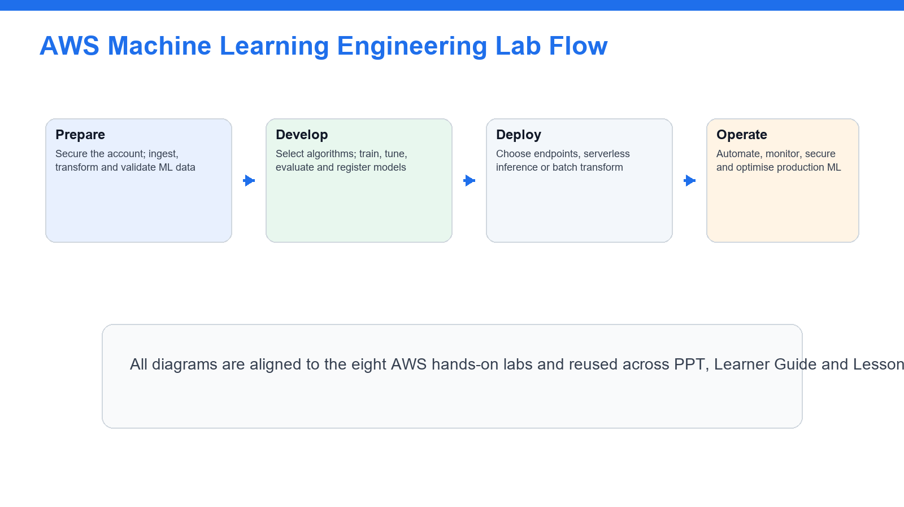
Use this flow to orient the labs: portal and shell basics first, then services, then governance.

Diagram - AWS Services Practised
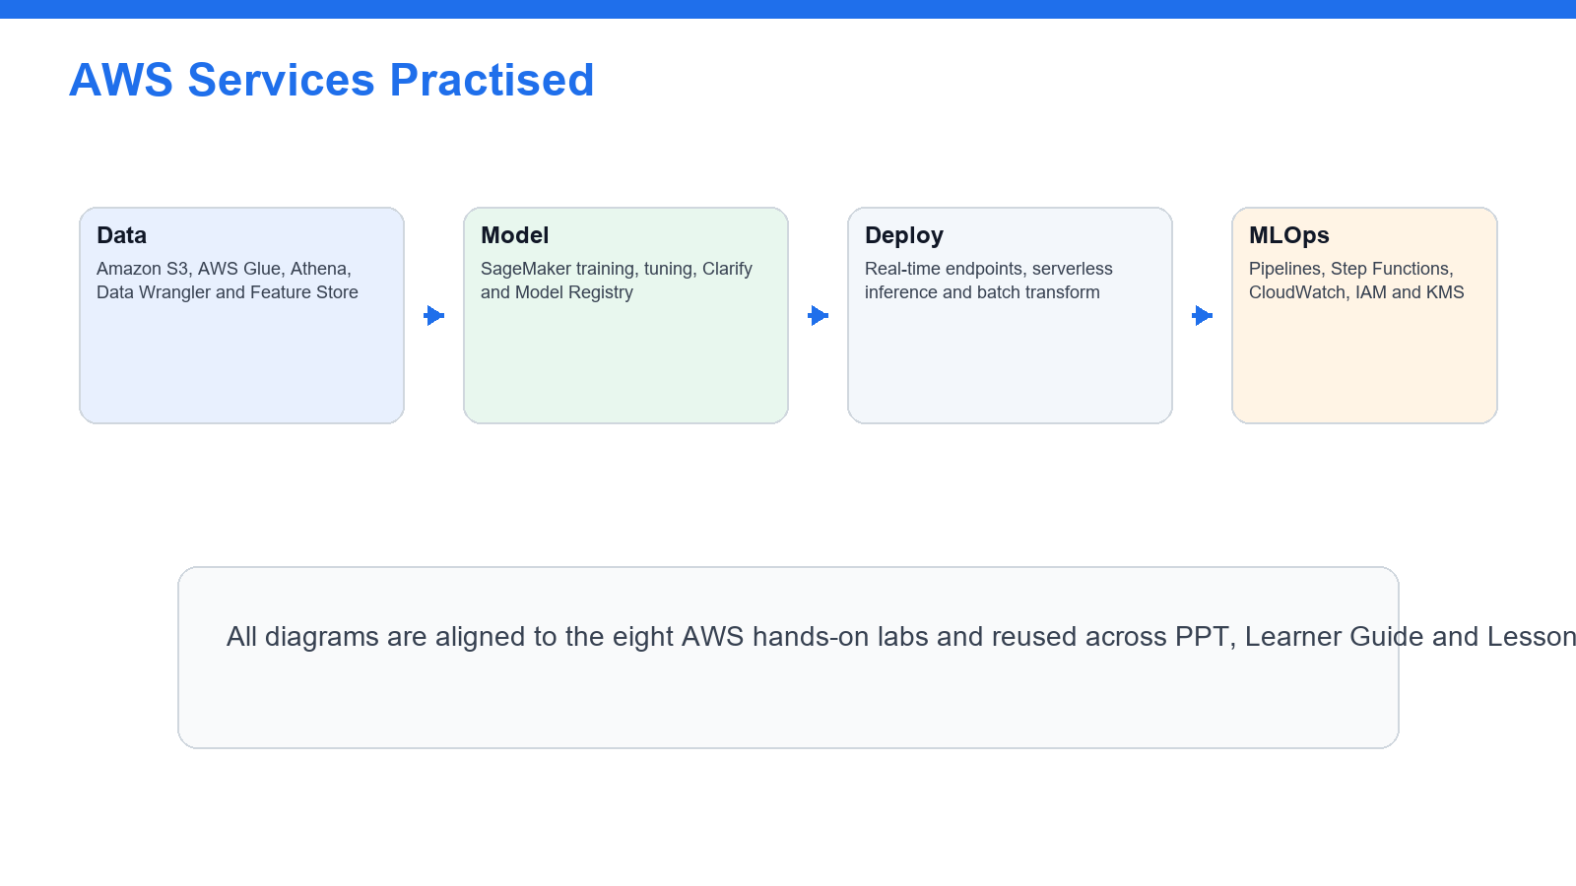
The eight labs cover data, modeling, deployment, MLOps, monitoring and governance services.

Diagram - AWS MLA-C01 Domain Weight Matrix
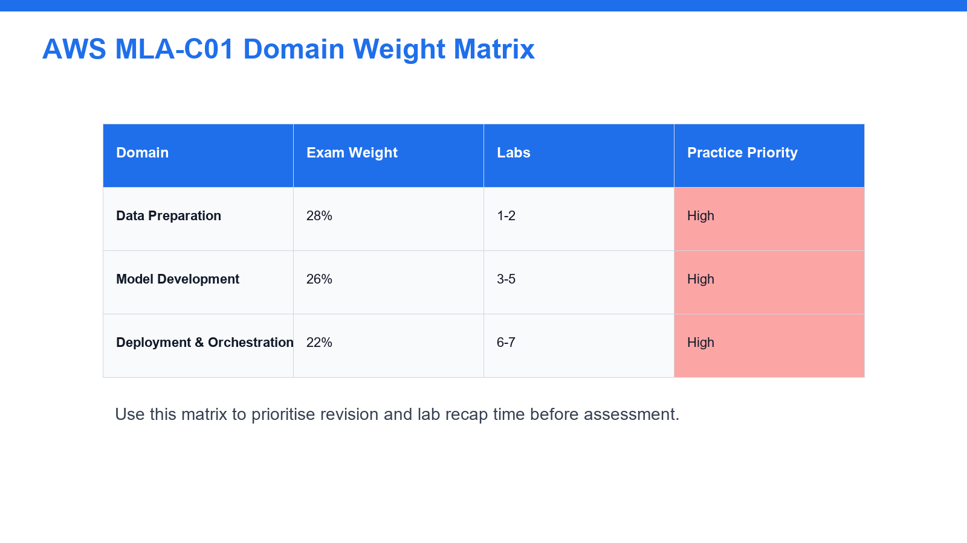
Use the matrix to prioritise recap time across the three AWS MLA-C01 exam domains.

Diagram - AWS Shared Responsibility Layers
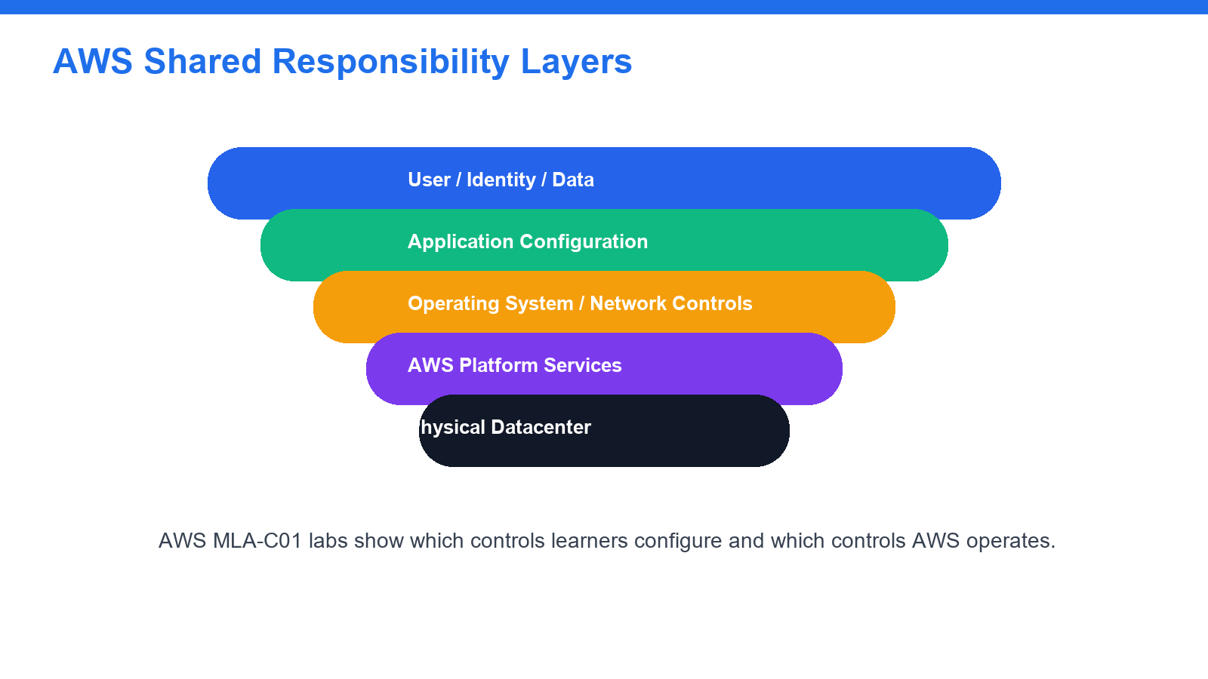
This layered model clarifies which cloud responsibilities learners configure in the labs.

Hands-On Lab Guide

Lab 1 - Account Safety, IAM, S3 ML Data Lake, and Data Formats

Note: Day 1 | Domain 1 - Data Preparation for Machine Learning | Source: labs/lab-01-account-iam-s3-ml-data-lake.md

Lab 1 Visual - Account Safety, IAM, S3 ML Data Lake, and Data Formats

Use this visual to connect the lab tasks to the end-to-end AWS machine-learning engineering workflow.

Objectives
- Configure a safe AWS learning baseline for ML engineering.
- Review IAM roles, policies, and least privilege for SageMaker and data services.
- Create an S3 ML data lake structure if permitted.
- Compare common ML data formats.

Scenario
Machine learning projects require secure access, controlled storage, and data formats that support training and inference workflows. This lab establishes the baseline for later ML tasks.

Steps
- Sign in to the AWS account assigned by your trainer.
- Confirm you are in the correct region.
- Open IAM and review users, roles, groups, and policies.
- Verify MFA where permitted.
- Review least-privilege access for S3, SageMaker, Glue, Athena, KMS, and CloudWatch.
- Open SageMaker and review execution role concepts.
- Open S3.
- Create a bucket only if your trainer permits it.
- Enable default encryption.
- Keep Block Public Access enabled.
- Create prefixes named `raw/`, `prepared/`, `features/`, `training/`, `models/`, and `monitoring/`.
- Upload small sample CSV and JSON files to `raw/` if permitted.
- Review object metadata and storage class.
- Create a table comparing CSV, JSON, Parquet, ORC, Avro, and RecordIO.
- Record which formats are best for analytics, streaming, and training workflows.
- Open KMS and review customer managed key concepts.
- Save your notes.

Deliverables
- IAM and least-privilege notes
- S3 ML data lake prefix structure
- Data format comparison table
- Encryption and cost safety notes

Checkpoint
You should be able to explain how IAM, S3, encryption, and data formats support ML engineering on AWS.

Lab 2 - Data Ingestion, Transformation, Feature Engineering, and Data Quality

Note: Day 1 | Domain 1 - Data Preparation for Machine Learning | Source: labs/lab-02-data-ingestion-feature-engineering-quality.md

Lab 2 Visual - Data Ingestion, Transformation, Feature Engineering, and Data Quality

Use this visual to connect the lab tasks to the end-to-end AWS machine-learning engineering workflow.

Objectives
- Compare data ingestion and transformation services for ML workflows.
- Review feature engineering techniques.
- Understand data quality, labeling, and bias checks.
- Design a raw-to-training data preparation workflow.

Scenario
ML models depend on high-quality, well-prepared data. You will design a workflow for ingesting, cleaning, transforming, labeling, and validating data.

Steps
- Open AWS Glue.
- Review crawlers, jobs, Data Catalog, and Glue Data Quality concepts.
- Open SageMaker Data Wrangler or review its documentation if access is unavailable.
- Review transformations such as missing-value imputation, normalization, standardization, binning, and one-hot encoding.
- Open SageMaker Feature Store or review feature group concepts.
- Record online and offline feature store use cases.
- Open SageMaker Ground Truth or review labeling job concepts.
- Review labeling use cases for text, image, and tabular data.
- Review SageMaker Clarify concepts for data bias detection.
- Create a feature engineering checklist for a sample customer churn dataset.
- Create a data quality checklist covering nulls, duplicates, schema mismatch, outliers, class imbalance, and data leakage.
- Design a pipeline from S3 raw data to prepared features in S3 or Feature Store.
- Identify which services would transform batch data and streaming data.
- Save your notes.

Deliverables
- Data preparation workflow
- Feature engineering checklist
- Data quality and bias checklist
- Service selection notes

Checkpoint
You should be able to explain how AWS services prepare data, features, labels, and quality checks for ML modeling.

Lab 3 - Modeling Approach, SageMaker Algorithms, JumpStart, and AI Services

Note: Day 1 | Domain 2 - ML Model Development | Source: labs/lab-03-modeling-approach-sagemaker-ai-services.md

Lab 3 Visual - Modeling Approach, SageMaker Algorithms, JumpStart, and AI Services

Use this visual to connect the lab tasks to the end-to-end AWS machine-learning engineering workflow.

Objectives
- Choose ML approaches based on business problems and data.
- Compare SageMaker built-in algorithms, custom training, JumpStart, Bedrock, and AI services.
- Review interpretability, cost, and feasibility tradeoffs.
- Create a model selection matrix.

Scenario
ML engineers must select the right model approach before training. Some problems require custom models, while others can use managed AI services or foundation models.

Steps
- Review common ML problem types: classification, regression, clustering, forecasting, anomaly detection, NLP, and computer vision.
- Open SageMaker or SageMaker documentation.
- Review built-in algorithm categories.
- Review script mode for custom frameworks such as TensorFlow, PyTorch, or scikit-learn.
- Open SageMaker JumpStart and review prebuilt models or solution templates.
- Open Amazon Bedrock and review foundation model use cases if available.
- Review AI services such as Rekognition, Translate, Transcribe, Comprehend, and Textract.
- Create a model/service selection table for five business scenarios.
- Include data type, expected output, candidate service, interpretability need, cost consideration, and operational complexity.
- Identify when an AI service is better than training a custom model.
- Identify when a SageMaker training job is more appropriate.
- Save your notes.

Deliverables
- ML problem type notes
- SageMaker and AI service comparison table
- Model/service selection matrix
- Cost and interpretability notes

Checkpoint
You should be able to choose an AWS modeling approach based on data, business outcome, cost, and operational requirements.

Lab 4 - Training, Hyperparameter Tuning, and Model Registry

Note: Day 1 | Domain 2 - ML Model Development | Source: labs/lab-04-training-tuning-model-registry.md

Lab 4 Visual - Training, Hyperparameter Tuning, and Model Registry

Use this visual to connect the lab tasks to the end-to-end AWS machine-learning engineering workflow.

Objectives
- Review SageMaker training job concepts.
- Understand epochs, batch size, steps, regularization, and overfitting controls.
- Design a hyperparameter tuning strategy.
- Manage model versions with Model Registry.

Scenario
After choosing a modeling approach, ML engineers need repeatable training, tuning, evaluation, and versioning workflows.

Steps
- Open SageMaker Training jobs.
- Review training input, output path, instance type, container image, and execution role concepts.
- Review script mode and framework estimator concepts.
- Record the meaning of epoch, batch size, learning rate, steps, and early stopping.
- Review regularization techniques such as L1, L2, dropout, pruning, and feature selection.
- Review distributed training and cost tradeoffs.
- Open Automatic Model Tuning concepts.
- Compare random search, grid search, and Bayesian optimization at a high level.
- Create a tuning plan for a sample classification model.
- Include objective metric, hyperparameters, ranges, stopping condition, and cost limit.
- Open Model Registry.
- Review model package groups, versions, approval status, and metadata.
- Design a model versioning workflow from training to approval.
- Save your notes.

Deliverables
- Training job concept notes
- Hyperparameter tuning plan
- Regularization and overfitting notes
- Model Registry workflow

Checkpoint
You should be able to explain repeatable model training, tuning, and version control on AWS.

Lab 5 - Model Evaluation, Performance Metrics, and Bias Analysis

Note: Day 2 | Domain 2 - ML Model Development | Source: labs/lab-05-model-evaluation-performance-bias.md

Lab 5 Visual - Model Evaluation, Performance Metrics, and Bias Analysis
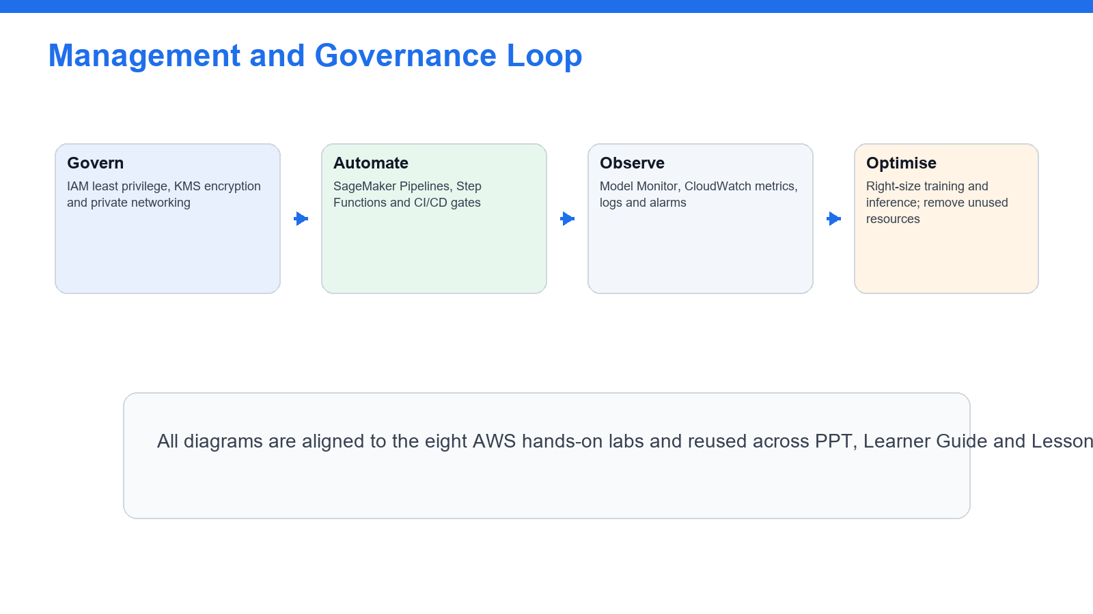
Use this visual to connect the lab tasks to the end-to-end AWS machine-learning engineering workflow.

Objectives
- Compare model evaluation metrics.
- Diagnose overfitting, underfitting, and poor generalization.
- Review bias and explainability tools.
- Build an evaluation and acceptance checklist.

Scenario
Models should not be promoted based on training accuracy alone. This lab covers evaluation metrics, model behavior, bias, and performance analysis.

Steps
- Create a table of model types and evaluation metrics.
- Include classification metrics such as accuracy, precision, recall, F1 score, ROC AUC, and confusion matrix.
- Include regression metrics such as MAE, MSE, RMSE, and R-squared.
- Include ranking or recommendation metrics if assigned by your trainer.
- Review what overfitting and underfitting look like in train and validation metrics.
- Review class imbalance and data leakage examples.
- Open SageMaker Clarify or review its documentation.
- Record bias metrics and explainability concepts.
- Review feature importance and SHAP value concepts at a high level.
- Design an evaluation plan for a binary classification model.
- Define train, validation, and test split strategy.
- Define minimum acceptable metrics and approval criteria.
- Define bias, fairness, and explainability checks.
- Save your notes.

Deliverables
- Evaluation metric comparison table
- Overfitting and underfitting notes
- Bias and explainability notes
- Model acceptance checklist

Checkpoint
You should be able to choose model metrics, interpret evaluation results, and identify when more data preparation or tuning is needed.

Lab 6 - Deployment Infrastructure, Endpoints, Batch Transform, and Auto Scaling

Note: Day 2 | Domain 3 - Deployment and Orchestration of ML Workflows | Source: labs/lab-06-deployment-endpoints-inference-infrastructure.md

Lab 6 Visual - Deployment Infrastructure, Endpoints, Batch Transform, and Auto Scaling

Use this visual to connect the lab tasks to the end-to-end AWS machine-learning engineering workflow.

Objectives
- Compare SageMaker deployment options.
- Review real-time endpoints, serverless inference, asynchronous inference, and batch transform.
- Understand auto scaling and endpoint monitoring.
- Select infrastructure based on requirements.

Scenario
ML models need different deployment patterns depending on latency, throughput, cost, and architecture. This lab focuses on inference infrastructure choices.

Steps
- Open SageMaker Inference or review deployment documentation.
- Review real-time endpoint concepts.
- Review serverless inference concepts.
- Review asynchronous inference concepts.
- Review batch transform concepts.
- Review multi-model endpoints and multi-container endpoints at a high level.
- Review model artifact, container image, endpoint configuration, and endpoint concepts.
- Review endpoint auto scaling metrics such as invocations per instance.
- Create an inference option comparison table.
- Include latency, throughput, payload size, traffic pattern, cost, scaling, and operational complexity.
- Choose a deployment option for online fraud scoring, nightly batch scoring, image processing, and bursty chatbot requests.
- Identify where CloudWatch metrics and logs are collected.
- Identify rollback or blue/green deployment considerations.
- Save your notes.

Deliverables
- Inference deployment comparison table
- Use-case deployment choices
- Auto scaling and monitoring notes
- Rollback and operations checklist

Checkpoint
You should be able to choose an ML deployment option based on latency, traffic, cost, and operational needs.

Lab 7 - MLOps Pipelines, CI/CD, and Workflow Orchestration

Note: Day 2 | Domain 3 - Deployment and Orchestration of ML Workflows | Source: labs/lab-07-mlops-pipelines-cicd-orchestration.md

Lab 7 Visual - MLOps Pipelines, CI/CD, and Workflow Orchestration

Use this visual to connect the lab tasks to the end-to-end AWS machine-learning engineering workflow.

Objectives
- Design an ML workflow from data preparation to deployment.
- Compare SageMaker Pipelines, Step Functions, CodePipeline, and EventBridge.
- Add approval, validation, rollback, and monitoring gates.
- Understand infrastructure as code and automation patterns.

Scenario
Production ML requires orchestration across data, training, evaluation, model registration, deployment, and monitoring. This lab designs an MLOps pipeline.

Steps
- Open SageMaker Pipelines or review its documentation.
- Review pipeline steps such as processing, training, tuning, condition, register model, and callback.
- Open Step Functions and review workflow orchestration concepts.
- Open CodePipeline and CodeBuild for CI/CD concepts.
- Open EventBridge and review event-driven triggers.
- Create a comparison table for SageMaker Pipelines, Step Functions, CodePipeline, and EventBridge.
- Design an ML pipeline with ingest, validate, feature engineering, train, tune, evaluate, register, approve, deploy, and monitor steps.
- Add failure paths and retry behavior.
- Add human approval for model promotion.
- Identify where IaC such as CloudFormation, CDK, or SageMaker project templates could be used.
- Identify where version control and artifact storage are used.
- Save your pipeline design.

Deliverables
- MLOps orchestration comparison table
- End-to-end ML pipeline design
- Approval and rollback notes
- CI/CD and IaC notes

Checkpoint
You should be able to describe how automated ML workflows move models from development to production safely.

Lab 8 - Monitoring, Security, Cost Optimization, and Exam Review

Note: Day 2 | Domain 3 - Deployment and Orchestration of ML Workflows | Source: labs/lab-08-monitoring-security-cost-exam-review.md

Lab 8 Visual - Monitoring, Security, Cost Optimization, and Exam Review
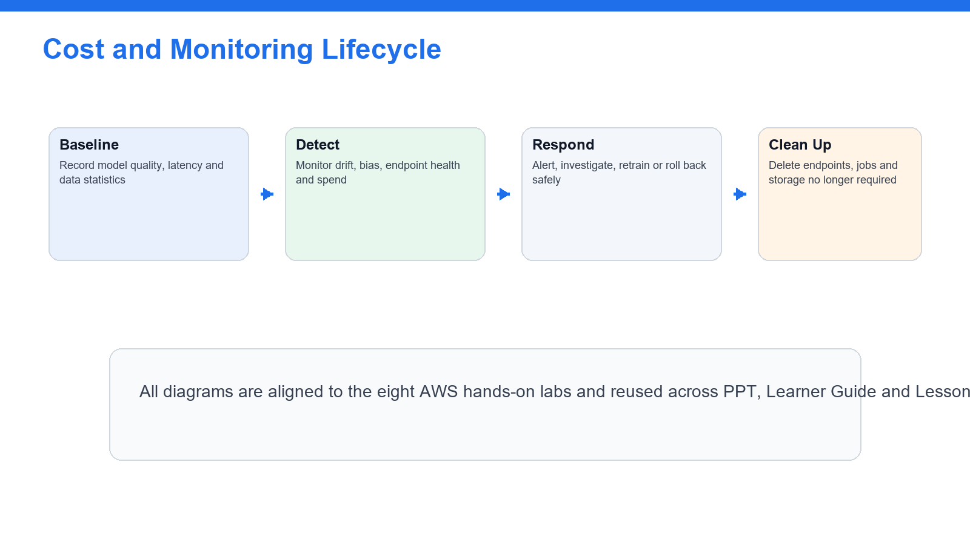
Use this visual to connect the lab tasks to the end-to-end AWS machine-learning engineering workflow.

Objectives
- Monitor data, models, endpoints, and infrastructure.
- Apply ML security and compliance controls.
- Optimize ML costs.
- Complete certification-style review practice.

Scenario
The final lab connects monitoring, maintenance, security, cost, and exam readiness for AWS ML engineering workloads.

Steps
- Open SageMaker Model Monitor or review its documentation.
- Review data capture, baseline, data quality, model quality, bias drift, and feature attribution drift concepts.
- Open CloudWatch.
- Review endpoint metrics, logs, alarms, dashboards, and anomaly detection.
- Open CloudTrail and review audit events.
- Review IAM roles, least privilege, resource policies, and SageMaker execution roles.
- Review KMS encryption, VPC endpoints, private subnets, and network isolation concepts.
- Review data classification, masking, anonymization, PII, PHI, and data residency concepts.
- Create a monitoring checklist for data drift, model quality, latency, errors, cost, and security events.
- Create a cost optimization checklist covering instance choice, endpoint autoscaling, serverless inference, batch transform, spot training, storage class, and stopping idle notebooks.
- Map each lab to the exam domains.
- Complete a timed 30-question practice set from trainer-provided questions or AWS practice resources.
- Mark weak topics by domain.
- Clean up temporary resources if instructed.
- Save final notes.

Deliverables
- ML monitoring checklist
- Security and compliance checklist
- Cost optimization checklist
- Timed practice score
- Weak-topic revision plan

Checkpoint
You should be ready to explain AWS ML engineering services, data preparation, model development, deployment, monitoring, security, and exam-style scenario choices.

